SIMATS ENGINEERING (SAVEETHA SCHOOL OF ENGINEERING)
Department of Computer Science and Engineering
ASSESSMENT TOOL 1 – CONCEPT MAP

Course Code: | ITA0305 | Course Title: | Mobile computing
CO Assessed: | CO1 | Assessment: | Assessment Tool 1 – Concept Map
Weightage: | 60 % of CIA | Total Marks: | 20 marks
CO1 Statement: | Analyse the mobile network components, mobile base station, mobile infrastructures and protocols in cellular systems.
Student Name: | PAVITHRA K | Reg. No.: | 192411027
Section / Batch: | 3RD YEAR | Date: | 10.10.2026

Code of Conduct

I PAVITHRA K - 192411027 (Name / Reg. No) certify that this submission is my original work and that I have adhered to the guidelines specified for this assessment. I understand that any violation of academic integrity rules will result in disciplinary action.
Signature of the Student: PAVITHRA K

Instructions
- This test contains ONE question.
- Duration: 30 minutes (At home)

Rubrics for Calculation

Criteria | Weightage | Level 4 – Exemplary | Level 3 – Proficient | Level 2 – Developing | Level 1 – Beginning
Understanding of Problem Context | 4 | Clearly understands the problem and accurately identifies all requirements | Good understanding with minor gaps | Basic understanding; some requirements unclear | Poor understanding or misinterpretation of the problem
Application of Concepts | 6 | Accurately applies appropriate concepts to solve complex problems | Applies relevant concepts correctly with minor errors | Applies basic concepts with limited accuracy | Fails to apply appropriate concepts
Problem-Solving Approach | 4 | Logical, well-structured, and efficient approach | Mostly logical approach with minor gaps | Basic approach with some inconsistencies | Illogical or unclear approach
Accuracy of Solution | 4 | Completely correct solution with proper justification | Mostly correct with minor errors | Partially correct solution | Incorrect or incomplete solution
Clarity | 2 | Clear, well-organized, and properly explained solution | Understandable with minor clarity issues | Limited clarity and explanation | Poorly presented and difficult to understand

Faculty In-charge | Course Coordinator | Program Director
Signature: _______________ | Signature: _______________ | Signature: _______________
Date: ___________________ | Date: ___________________ | Date: ___________________

Annexure A - QUESTIONS
1.Develop a concept map that evaluates the identities and numbers used in a PLMN.
Relate MSISDN, IMSI, TMSI, IMEI, MSRN, LAI and Cell Global Identity to their functions.
    - Assess which identity is most essential for routing a call to a roaming user.
    - Support your evaluation with meaningful concept relationships.
Introduction
A Public Land Mobile Network (PLMN) is a wireless communication network operated by a mobile service provider. It uses different identities and numbers to identify mobile subscribers, mobile devices, locations and calls. These identities support subscriber authentication, privacy, mobility management and call routing, especially when a subscriber travels outside their home network.
2. Functions of PLMN identities and numbers
- IMSI: International Mobile Subscriber Identity. It uniquely identifies a subscriber within the mobile network.
- TMSI: Temporary Mobile Subscriber Identity. It protects subscriber privacy by reducing the need to transmit the permanent IMSI over the radio interface.
- MSISDN: Mobile Station International Subscriber Directory Number. It is the telephone number used to call a mobile subscriber.
- IMEI: International Mobile Equipment Identity. It identifies the mobile device and supports equipment verification.
- MSRN: Mobile Station Roaming Number. It provides temporary routing information for incoming calls to roaming subscribers.
- LAI: Location Area Identity. It identifies a location area containing multiple cells and supports mobility management.
- CGI: Cell Global Identity. It identifies a specific cell within a cellular network.
3. Relationship between the identities
These identities work together to provide reliable mobile communication. The IMSI identifies the subscriber, while the TMSI improves privacy. The MSISDN allows other users to call the subscriber, and the IMEI identifies the device. The LAI and CGI provide location information at the location-area and individual-cell levels. The MSRN supports incoming call routing when the subscriber is roaming.
4. Importance of MSRN in roaming
When a subscriber travels to another network, the subscriber is said to be roaming. When someone calls that subscriber, the home network uses subscriber information maintained in the HLR to obtain routing information from the visited network. The MSRN helps route the call through the visited network to the subscriber's serving MSC and mobile station.
Therefore, MSRN is the most directly important number for routing an incoming call to a roaming subscriber, while IMSI is essential for subscriber identification and MSISDN is used as the dialled telephone number.
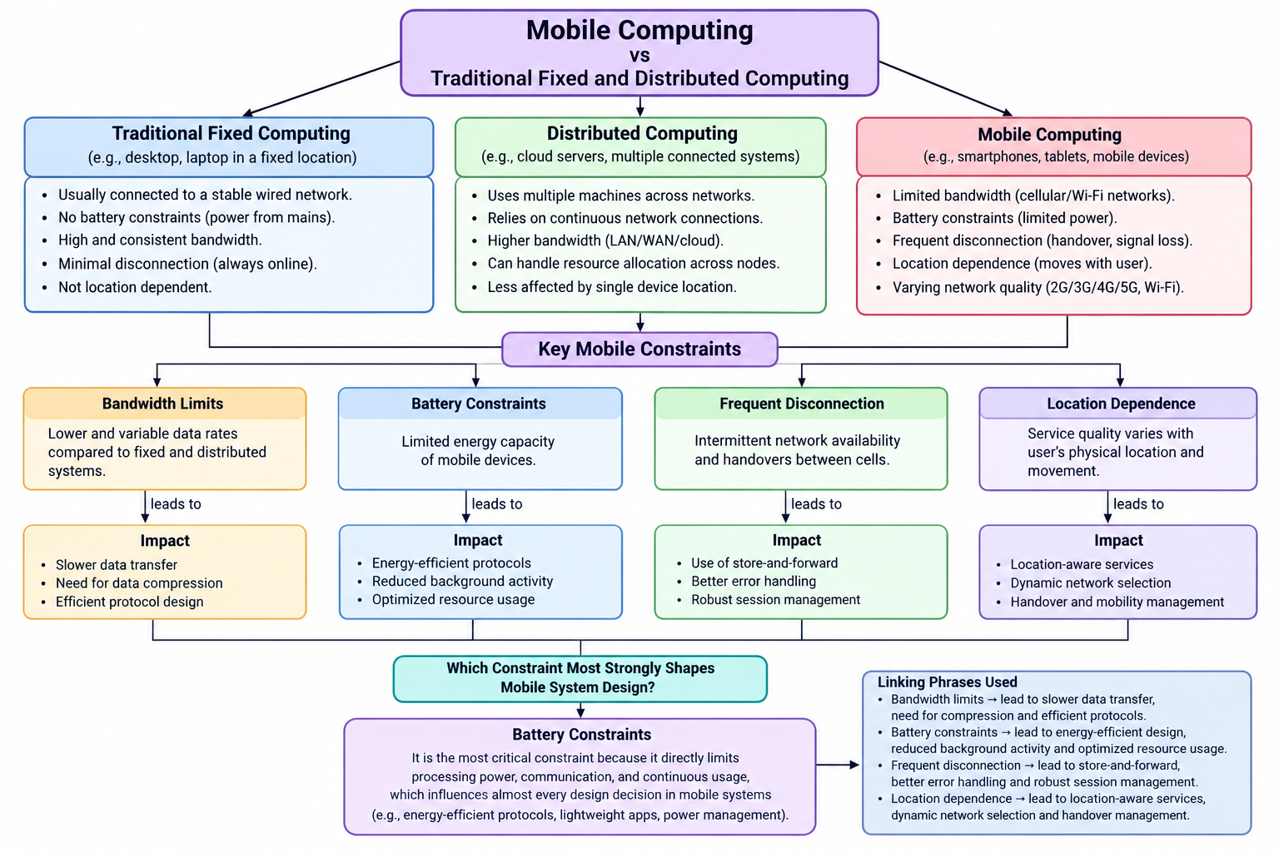
A PLMN (Public Land Mobile Network) is a mobile communication network operated by a mobile service provider. It uses different identities and numbers to identify subscribers, mobile equipment, geographical locations and calls.
The seven important identities and numbers are:
- IMSI – International Mobile Subscriber Identity
- TMSI – Temporary Mobile Subscriber Identity
- MSISDN – Mobile Station International Subscriber Directory Number
- IMEI – International Mobile Equipment Identity
- MSRN – Mobile Station Roaming Number
- LAI – Location Area Identity
- CGI – Cell Global Identity
Each serves a different purpose, and they work together to support authentication, privacy, mobility management and call routing.
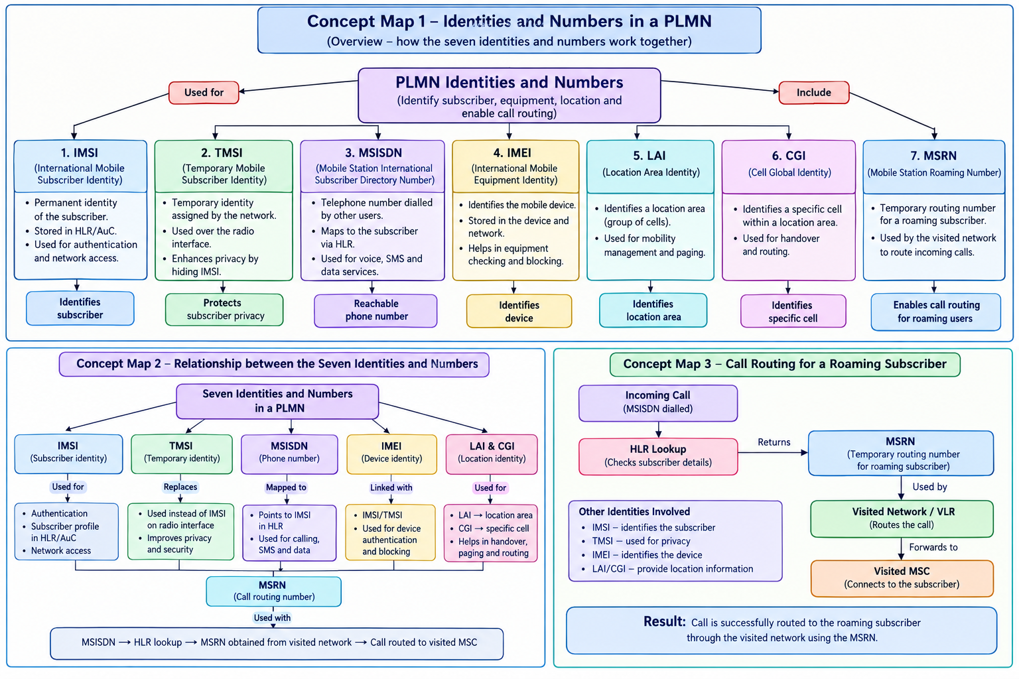

Explanation of the relationships
1. IMSI and TMSI: The IMSI identifies the subscriber permanently within the mobile network. The network can assign a TMSI for temporary identification, reducing the exposure of the permanent identity over the radio interface.
2. MSISDN and IMSI: The MSISDN is the number people dial, whereas the IMSI identifies the subscriber internally. The network uses subscriber records to associate the dialled number with the correct subscriber.
3. IMEI: Unlike the IMSI, which identifies the subscriber, the IMEI identifies the mobile equipment. Equipment identity checks can help detect devices that should not be allowed on the network.
4. LAI and CGI: The LAI identifies a location area consisting of multiple cells. The CGI identifies a particular cell, enabling the network to determine a more specific cell identity.
5. MSRN: When a subscriber is roaming, the network can obtain an MSRN from the visited network to support routing an incoming call to that subscriber.

Conclusion
PLMN identities and numbers perform different but interconnected functions. IMSI and TMSI support subscriber identification and privacy, MSISDN enables telephone calls, IMEI identifies equipment, and LAI and CGI support location management. MSRN provides temporary routing information for roaming calls. Together, these identities improve the efficiency, security and reliability of cellular communication.

